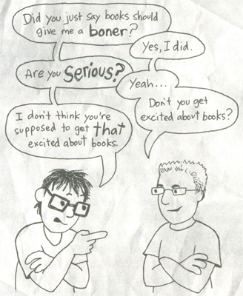
EMU Common Reads
2013-2014

The Absolutely True Diary of a Part-time Indian
by Sherman Alexie, Art by Ellen Forney

Description of EMU Common Reads: Intellectual Life will host a series of 4-5 events spread throughout the school year that invite faculty, staff, and students into conversation around a common reading. This program is intended to build community across campus by providing us a common experience, to encourage us to reflect on EMU’s Mission and to connect our in-class learning with extracurricular events happening on campus.
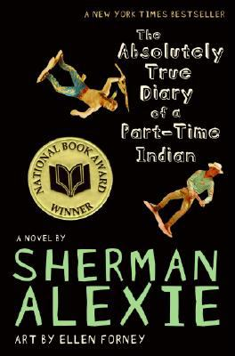
The Absolutely True Diary of a Part-Time Indian is based in part on Alexie’s own experiences. In the Diary, Junior chronicles through words and cartoons his struggle to find his identity and future as he leaves the Spokane Indian Reservation to seek a better education at an all-white rural high school.

This book invites us to consider
- Life changing cross-cultural encounter that can happen in our own backyard: how do we hear others voices, respect our past, and find our own?
- Service with compassion: how do we maintain our identity while being hospitable?
- Offering healing & hope in a diverse world: what is an Anabaptist response to disability, rejection, bullying, trauma recovery, land rights issues, poverty, and discrimination?

