Copyright Issues in Videography

- Copyright your own work, starting with the script….
  - For example: © Roman Miller 2016
  - The copyright notice informs the public that you are the creator and owner of the material, i.e. the script or video.
  - You may option to “register” your copyright work with the copyright office [http://www.copyright.gov/], but this costs money. ($35-85)
- Find materials and sources in the production of your video.
  - The best approach is to create your own rather than copying diagrams, pictures, music, etc. from the internet; alternatively if you get permission from the owner of the picture or diagram then it can be used in its original form and credited.
  - Plagiarism involves using someone else’s words, pictures, music, diagrams, etc. as your own work.
  - Someone else’s ideas can be used (with appropriate crediting) in your own work with appropriate modification, e.g.
    - Data graph or table: redraw graph or reconfigure table and credit original data source
    - Textual information: rewrite script in your own words and credit original informational source
  - If you need still pictures, take your own and insert into your video. Some internet sites that list free stock photos can be found here: http://www.entrepreneur.com/article/238646
  - If you want music, check the internet for sources of “free” music or create your own (maybe with the help of friends). Examples of free music source: http://www.freestockmusic.com/ or http://www.adweek.com/socialtimes/royalty-free-music/38475
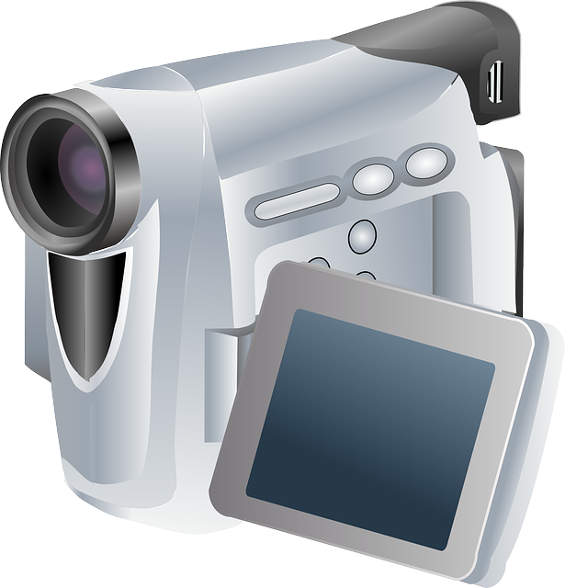

For example, this picture to the right was downloaded from the website Pixabay: https://pixabay.com/

