Activity 2: More on Data Types

Java supports two main types of data: primitive types like int and double that represent a single value, and reference types like String and Scanner that represent more complex information.

## Content Learning Objectives

*After completing this activity, students should be able to:*

* Name Java’s primitive data types and give examples of each one.
* Identify illegal assignment statements and explain why they are illegal.
* Describe what it means for variables to store a reference to an object.

# Model 1 Primitive Types

|  |  |  |  |  |
| --- | --- | --- | --- | --- |
| **Keyword** | **Size** | **Min Value** | **Max Value** | **Example** |
| byte | 1 byte | *−*128 | 127 | 123 |
| short | 2 bytes | *−*32,768 | 32,767 | 45 |
| int | 4 bytes | *−*231 | 231 − 1 | 1234567890 |
| long | 8 bytes | *−*263 | 263 − 1 | 123456789012345L |
| float | 4 bytes | *−*3.4 *×* 1038 | 3.4 × 1038 | 3.14159F  ❋ |
| double | 8 bytes | *−*1.8 *×* 10308 | 1.8 × 10308 | 3.141592653589793  ✷✻✺✸✺✽✾✼✾✸ |
| boolean | 1 byte |  |  | true |
| char | 2 bytes | 0 | 65,535 | ‘A’ |

Note that 1 byte is 8 bits, i.e., eight “ones and zeros” in computer memory. Since there are only two options for each bit, you can represent 28 = 256 possible values with 1 byte.

1. Which of the primitive types are integers? Which are floating-point?
2. Why do primitive types have ranges of values? What determines the range of the data type?
3. Why can’t computers represent every possible number in mathematics? Will they ever be able to do so?
4. Since a Byte can represent 256 different numbers, why is its max value 127 and not 128?
5. What is the data type for each of the following values?

1.14159 7.2E-4 -128

0 0.0 ‘0’

-1.0F -13L false

123 'H' true

1. Study the example below to know when Java allows you to assign one type of primitive variable to another

|  |  |
| --- | --- |
| int int_ = 3;  long long_ = 3L;  float float_ = 3.0F;  double double_ = 3.0;  int_ = int_;  int_ = long_; //  illegal  int_ = float_; //  illegal  int_ = double_; //  illegal  long_ = int_;  long_ = long_;  long_ = float_; //  illegal  long_ = double_; //  illegal | float_ = int_;  float_ = long_;  float_ = float_;  float_ = double_; // illegal  double_ = int_;  double_ = long_;  double_ = float_;  double_ = double_;  int_ = '0';  int_ = false; // illegal  double_ = '0';  double_ = false; // illegal |

1. Given the following variable declarations, which of the assignments are not allowed?

|  |  |
| --- | --- |
| byte miles;  short minutes;  int checking;  long days;  float total;  double sum;  boolean flag;  char letter; | checking = 56000;  total = 0;  sum = total;  total = sum;  checking = miles;  sum = checking;  flag = minutes;  days = '0'; |

1. About the data type double representation: internally these numbers are written as a product of two values, the mantissa and the exponent. This works similar to how numbers are written in scientific notation: for the number 1.23∗1024, the mantissa is 1.23 and the exponent is 24.

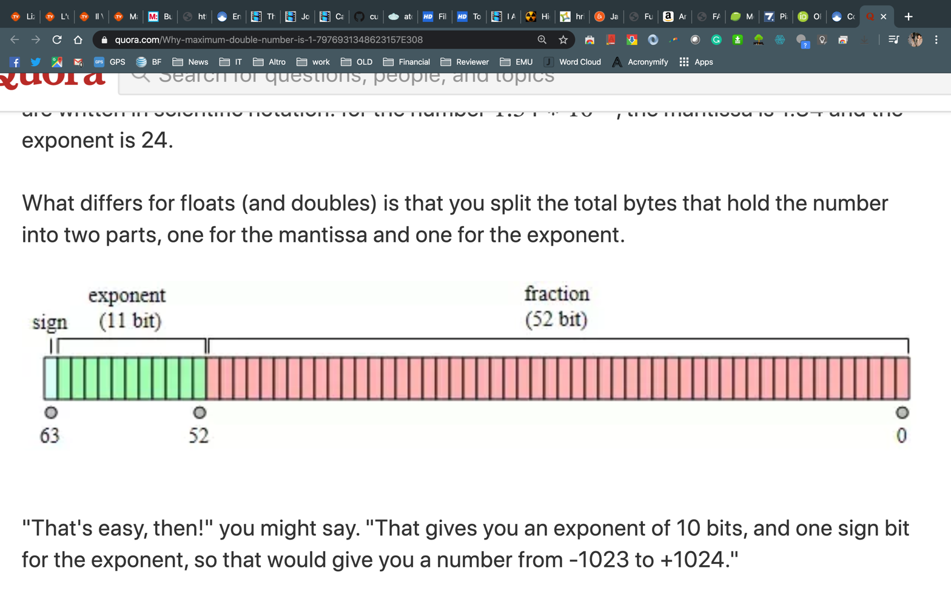

How to get that a double can store from -1.8 *×* 10308 to +1.8 *×* 10308 ?

1. A double and a long seem to use both 8 bytes, why do you think their range is so different?

# Model 3 Reference Types

int count;

double price;

String name;

Scanner in;

count = 0;

price = 1.99;

name = " Beyonce";

in = new Scanner(System.in);

Java has eight primitive types (see Model 1). All other types of data are called *reference* types, because **their value is a memory address (if this is not 100% clear, raise your hand!)**. When drawing memory diagrams, use an arrow to *reference* other memory locations (rather than make up integer values for the actual addresses).

1. What are the reference types in the example above?
2. By convention, what is the difference between primitive and reference type names?
3. Variables in Java can use at most eight bytes of memory. Explain why the values “Beyonce"

and System.in cannot be stored directly in the memory locations for name and in.

1. What is the value of the variable count What is the value of the variable price?
2. What is the value of the variable name? What is the value of the variable in? (this question might be tricky)
3. Carefully explain what it means to assign one variable to another. For example, what does the statement price = count; do in terms of memory?
4. Draw a memory diagram for the following code (be careful here over the last line!).

int width;

double score;

Scanner input;

String first;

String other;

width = 20;

score = 0.94;

input = new Scanner(System.in);

first = "Taylor";

score = width;

other = first;

1. What is the output of the following statements after running the code above? Explain your answer using the diagram (I suggest you try it on javac before you answer, or answer and cross-check the outcome of the compiler!)

first = "Swift";

System.out.println(other);