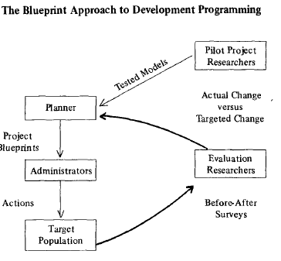
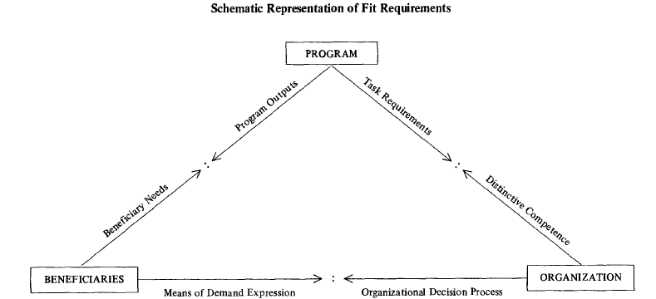

DAVID KORTEN'S "FIT REQUIREMENTS" FOR AN INSTITUTION

David Korten states that any learning process institutional model must take into consideration three dyads related to what he calls "fit requirements" for institutions. Each dyad pertains to one of three aspects of an institution's constituent parts:

1) THE PROGRAM,
2) THE ORGANIZATION, and
3) THE BENEFICIARIES

These three elements and their mutual interworking help determine the performance of any institution. In order to help ensure proper functioning,

Design of THE PROGRAM (P) must take into consideration:

(1) program outputs, and
(2) task requirements;

Structuring of THE ORGANIZATION (O) must take into consideration:

(1) the appropriate organizational decision processes, and
(2) the distinctive competence of the assisting organization to the context;

Assistance to THE BENEFICIARIES (B) must take into consideration:

(1) beneficiary needs, and
(2) the means of demand expression.

The way that this is done is by beneficiary needs being matched up with the outputs of any institution's programs, the possible means of expression of demand being matched with the decision process, and the task requirements being appropriate to the distinctive competence of the organization.

CONTROLLING FACTORS RESULTING IMPLEMENTATION

BENEFICIARY NEEDS (B) PROGRAM OUTPUTS (P)

MEANS OF EXPRESSION (B) DECISION PROCESS (O)

ORGANIZATIONAL COMPETENCE (O) TASK REQUIREMENTS (P)

It seems obvious that the most crucial of these three is the Beneficiary element, since both factors related to it (those elements labelled (B) above) are found in the Controlling Factors column.

In addition, the element of next importance would appear to be the Organizational Factor (O), with one of its components also listed under the Controlling Factors column.

In contrast, both Program elements (P) appear under the Resulting Implementation column. Hence, the structure of the program needs to be adapted to the capacities of the organization, which in turn needs previously to be fashioned around those factors related to proposed beneficiaries.

However, the critical link between beneficiary needs and ultimate program outputs still needs to be borne in mind, seeing as how the two are intrinsically linked in the functioning of any program (as evidenced by the coupling of these two factors above.)

With these factors considered, it will be more likely that real needs (both immediate and long term) will be addressed by the institution implemented.

